Lab Report

Purpose: To do a classification task on MNIST dataset by using Convolution Neural Network and estimate the hyperparameter by random search.

**Notes**: Since my laptop is malfunctioning at the last moment before the deadline, I could not be able to complete all the steps. I could not install the hpbandster library packages also. It is giving me the following error:

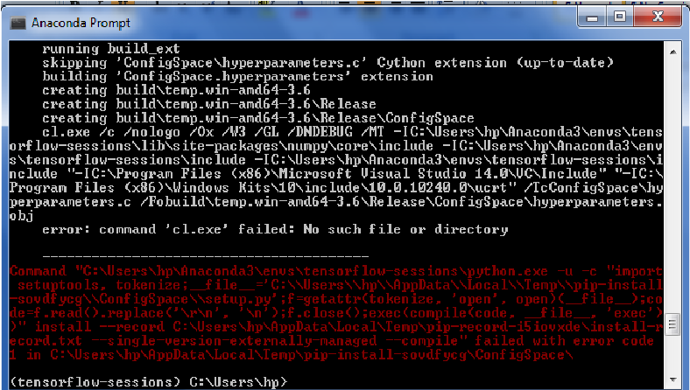

So I couldn't test my code completely. I, therefore, submitting my code as it is, with my past observations.

Observation:

**Tests with Filter size 3 X 3:**

1) Learning Rate: 0.1

Number of Filters: 16

Batch Size: 128

Filter Size: 3

Epochs: 500

Accuracy: 0.9674

Loss: 0.11071386

It took around 40 minutes to run all the 500 epochs in my system.

2) Learning Rate: 0.01

Number of Filters: 16

Batch Size: 128

Filter Size: 3

Epochs: 500

Accuracy: 0.8847

Loss: 0.3769

It took around 45 minutes approximately to run all the 500 epochs in my system. It seems that accuracy is lower than the previous case.

3) Learning Rate: 0.001

Number of Filters: 16

Batch Size: 128

Filter Size: 3

Epochs: 500

Accuracy: 0.2865

Loss: 2.2457

4) Learning Rate: 0.0001

Number of Filters: 16

Batch Size: 128

Filter Size: 3

Epochs: 500

Accuracy: 0.09987

Loss: 2.3547

It seems that the validation accuracy is getting lower as we decrease the learning rate. Although it is likely that as we increase the number of epochs we might get a good validation accuracy on the data.

**Tests with Filter size 5 X 5:**

1) Learning Rate: 0.1

Number of Filters: 16

Batch Size: 128

Filter Size: 5

Epochs: 500

Accuracy: 0.9798

Loss: 0.100455

Total execution time is 1 hour 15 mins.